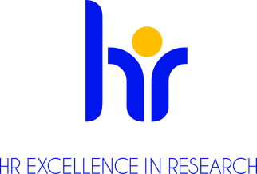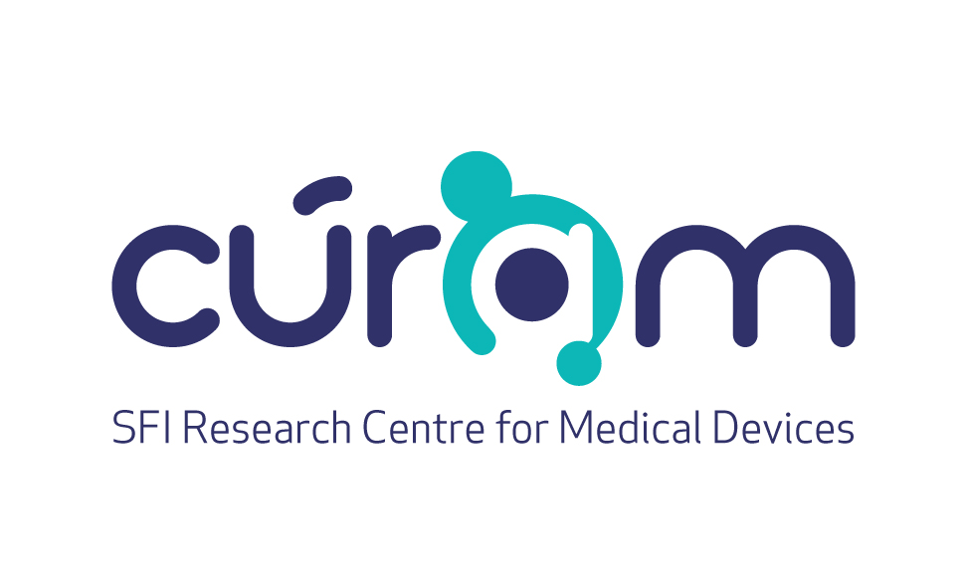



**Postdoctoral Research Fellow Position (EU)**

CÚRAM, SFI Research Centre for Medical Devices, National University of Ireland, Galway, Ireland

**Ref. No. NUIG RES 129-22**

Applications are invited from suitably qualified candidates for a full-time, fixed-term contract as Postdoctoral Research Fellow (EU) at the CÚRAM SFI Centre for Research in Medical Devices (National University of Ireland, Galway. The position is available from mid-June 2022 for 24 months, subject to an initial 12 month probation period. This position is funded by an EU Horizon 2020 grant.

**Organisation:** CÚRAM is a national, SFI-funded research centre that brings together researchers from NUI Galway, University College Dublin, Dublin City University, University of Limerick, University College Cork, Trinity College Dublin, and Royal College of Surgeons Ireland. The prime objective for CÚRAM is to radically improve health outcomes for patients by developing innovative implantable ‘smart’ medical devices to treat major unmet medical needs. Implants will be designed and manufactured to respond to the body’s environment and deliver therapeutic agents, such as drugs, exactly where needed. Cutting-edge science will develop devices using the latest research from biomaterials, stem cells and drug delivery and the support of clinical solid collaborations, industry partners and hospital groups to enable rapid translation to the clinic.

The candidate will be based in Professor Abhay Pandit’s research group. Professor Pandit’s research integrates material science and biological paradigms in developing solutions for chronic diseases. He has designed next-generation reservoir delivery vehicles with high payload capacity, programmable degradation profiles and inbuilt gradients of physical, chemotropic and protective cues, which facilitate spatiotemporal localised sustained delivery of multiple biomolecules to target injury mechanisms at the molecular and cellular levels. The biomaterial platforms have been validated to act as inductive templates for constructive remodelling and as templates for the induction of de novo functional, site-appropriate tissue formation. His current research focusses on characterising a glyco-host response to implants and disease states. These platforms have been developed for neural, musculoskeletal and cardiovascular clinical targets with numerous other targets currently under development.

**Job Description**: This is a prestigious two-year fellowship for eligible experienced researchers in the area of functional biomaterials at the interface of glycoscience and glycobiology . To apply, candidates are required to develop a project proposal in collaboration with Professor Pandit’s research area (details on their areas of research available at [www.nuigalway.ie/curam](http://www.nuigalway.ie/curam)).

The ideal candidate should hold a PhD in Biomedical Engineering, Life sciences with a strong background in regenerative medicine. The candidate will be expected to have performed original scientific research in the above area of domain. Candidates should have excellent communication and organizational skills, be highly motivated and passionate about designing the next generation of ‘smart’ medical devices and have strong documentation, oral and interpersonal skills. The position requires communication with the different partners of the consortium, and thus excellent communication skills are mandatory. The position also requires submission of grant applications to various funding bodies.

**Duties:**

* Plan, co-ordinate and implement specific aim of the project and coordinate with other partners
* achieve the objectives of the project
* Work independently to design and perform complex experiments and evaluate results and coordinate with other partners
* Training and supervision of current and new lab members is also required.
* Contribute to dissemination of research findings through publication and conferences.

**Essential Requirements:**

* PhD in Biomedical Engineering/Glycobiology/Glycochemistry/ Life sciences/ / Regenerative Medicine
* Demonstrable experience in both independent and collaborative research activities
* Excellent publications record in high impact factor journals
* Excellent verbal and **written** communication skills (English language)
* Evidence of scientific publication and dissemination of results at conferences
* Evidence of developing laboratory-based assays

**Desirable Requirements:**

* Minimum two **first-author publications** in a relevant high impact journal
* Experience in working in a team
* Experience in hands-on assays in Tissue Engineering/ Biomaterials/Stem cells/ Regenerative Medicine and related areas
* Evidence of innovative thinking, able to work both independently and in cross-disciplinary teams
* Appropriate supervisory or teaching experience may be an advantage
* Evidence of submission of funding applications

**Salary:** €39,523 - €51,034 per annum

**Start date:** June/July

Further information on research and working at NUI Galway is available on [Research at NUI Galway](http://www.nuigalway.ie/our-research/)

For information on moving to Ireland, please see [www. euraxess.ie](http://www.euraxess.ie)

For information about **CÚRAM.**, [http://www.curamdevices.ie](http://www.curamdevices.ie/)

For informal enquiries about this post, please contact Professor Abhay Pandit: [abhay.pandit@nuigalway.ie](mailto:abhay.pandit@nuigalway.ie)

**To Apply:**

Applications to include a covering letter, CV, and the contact details of three referees should be sent via e-mail (in word or PDF only) to Tara Cosgrave ([tara.cosgrave@nuigalway.ie](mailto:tara.cosgrave@nuigalway.ie)).

Please put reference number **NUIG RES 129-22** in the subject line of the e-mail application.

**The closing date for receipt of applications is 5.00 pm on the 7th of June 2022**

All positions are recruited in line with Open, Transparent, Merit (OTM) and Competency-based recruitment.

National University of Ireland, Galway is an equal opportunities employer.

