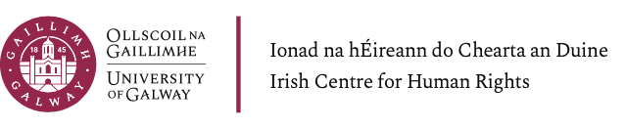

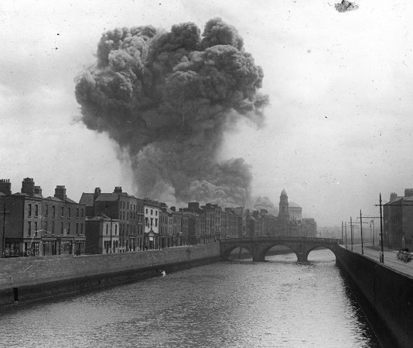

Civil Wars & International Laws
The Irish Civil War 1922-23 and the Evolving Laws of War

Friday 21 April 2023

Irish Centre for Human Rights
School of Law
University of Galway

Programme

10.00 Opening Remarks

10.15 Panel I – The Irish Civil War
- Dr John O’Callaghan, Atlantic Technological University, ‘Violence in the Irish Civil War: the descent into atrocity’
- Dr Mary McAuliffe, University College Dublin, ‘Militant women, gendered violence and the National Army during the Irish Civil War'

11.30 Tea/Coffee Break

11.45 Panel II – The International Context
- Dr Anthony Cullen, University of Middlesex, ‘Recognition of belligerency under the laws of war’
- Rémi Fuhrmann, University of Glasgow, ‘The 1918-1949 international legal discourse and civil war: between tradition and legal experimentation’

13:00 Lunch

14:00 Panel III – Internationalising and Applying the Laws of War in the Irish Civil War
- Dr Lia Brazil, University of Oxford, ‘Between national restrictions and international rights: women’s internationalism, the ICRC and the Irish Civil War’
- Professor Kimberly Lowe, Lesley University, ‘The International Red Cross Movement and the Irish Civil War’
- Professor Shane Darcy, University of Galway, ‘Prisoners of war, “civilized warfare” and the Irish Civil War’

To register go to: https://www.eventbrite.ie/e/the-irish-civil-war-1922-1923-and-the-evolving-laws-of-war-tickets-579256460667

